**Name (*Last, First*): Li Mengxi, ID: #301092480.**

/30

**Name (*Last, First*): Cong Wang, ID: #301098547.**

Note: Complete questions 4, 5 and 6 using SCILAB. Print or screenshot the output and attach it to this assignment.

***Late assignments will not be accepted.***

1. Use Jordan-Gauss elimination to solve the following system of linear equations: [5]

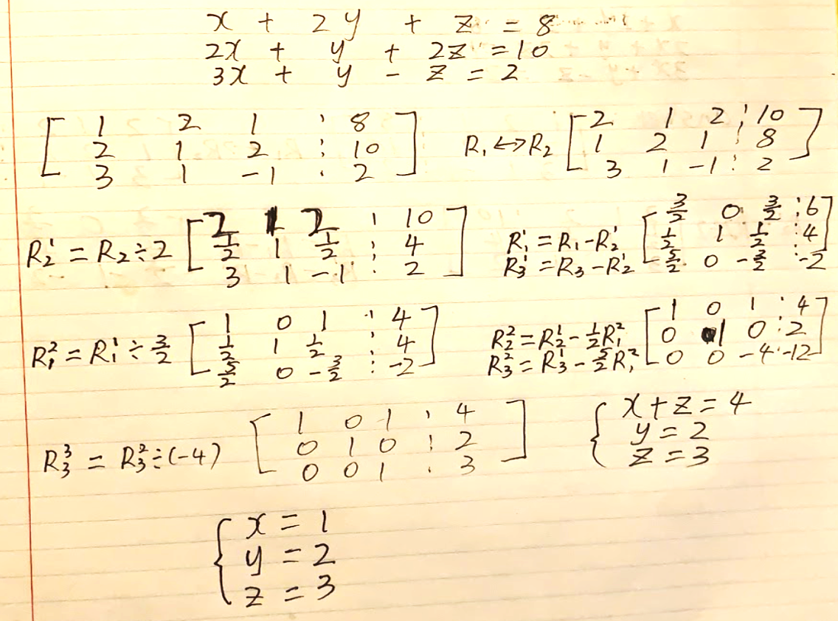

1. For the following system of homogenous linear equations: [5]

Use elementary row operations to solve the above system. Identify the free variable(s) if any.

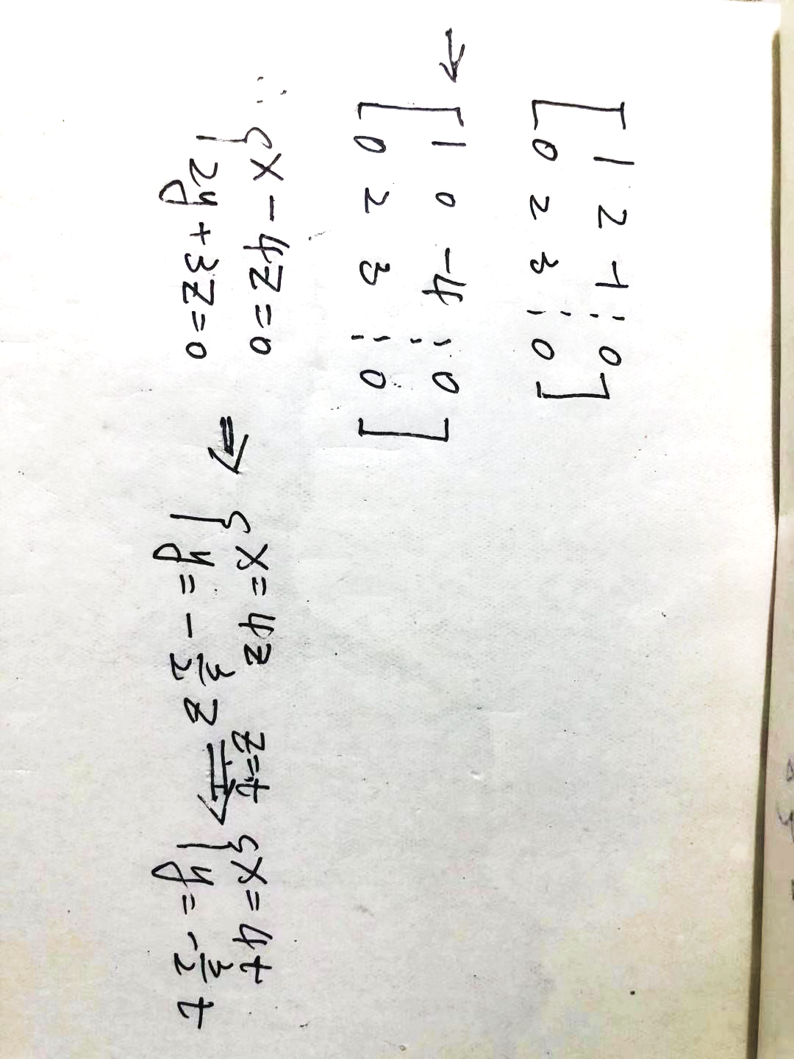

1. Given the following matrices: [11]

; C = ; D =



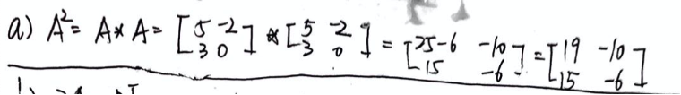

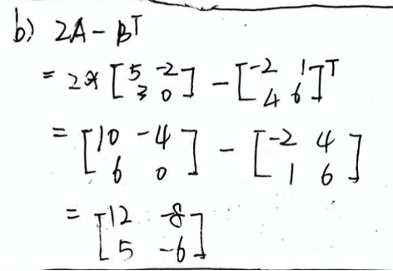

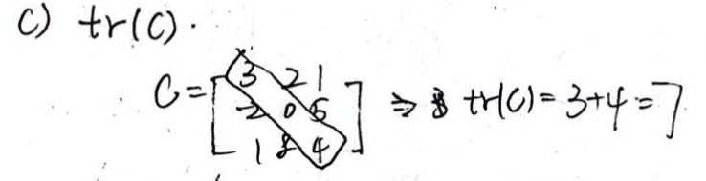

1. *where*

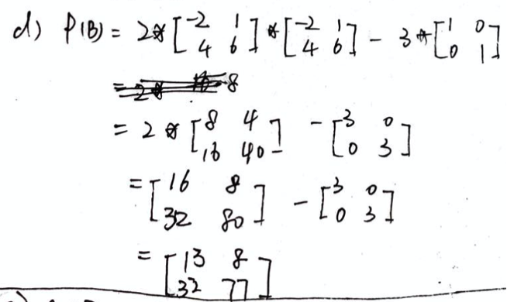

e)

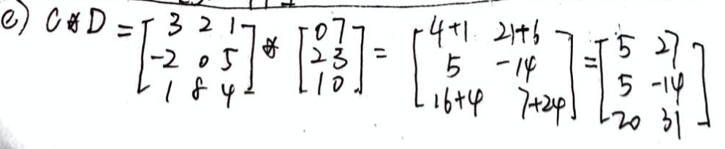

4. Use *SCILAB* to solve problem number 3d) again and attach SCILAB window environment: [3] 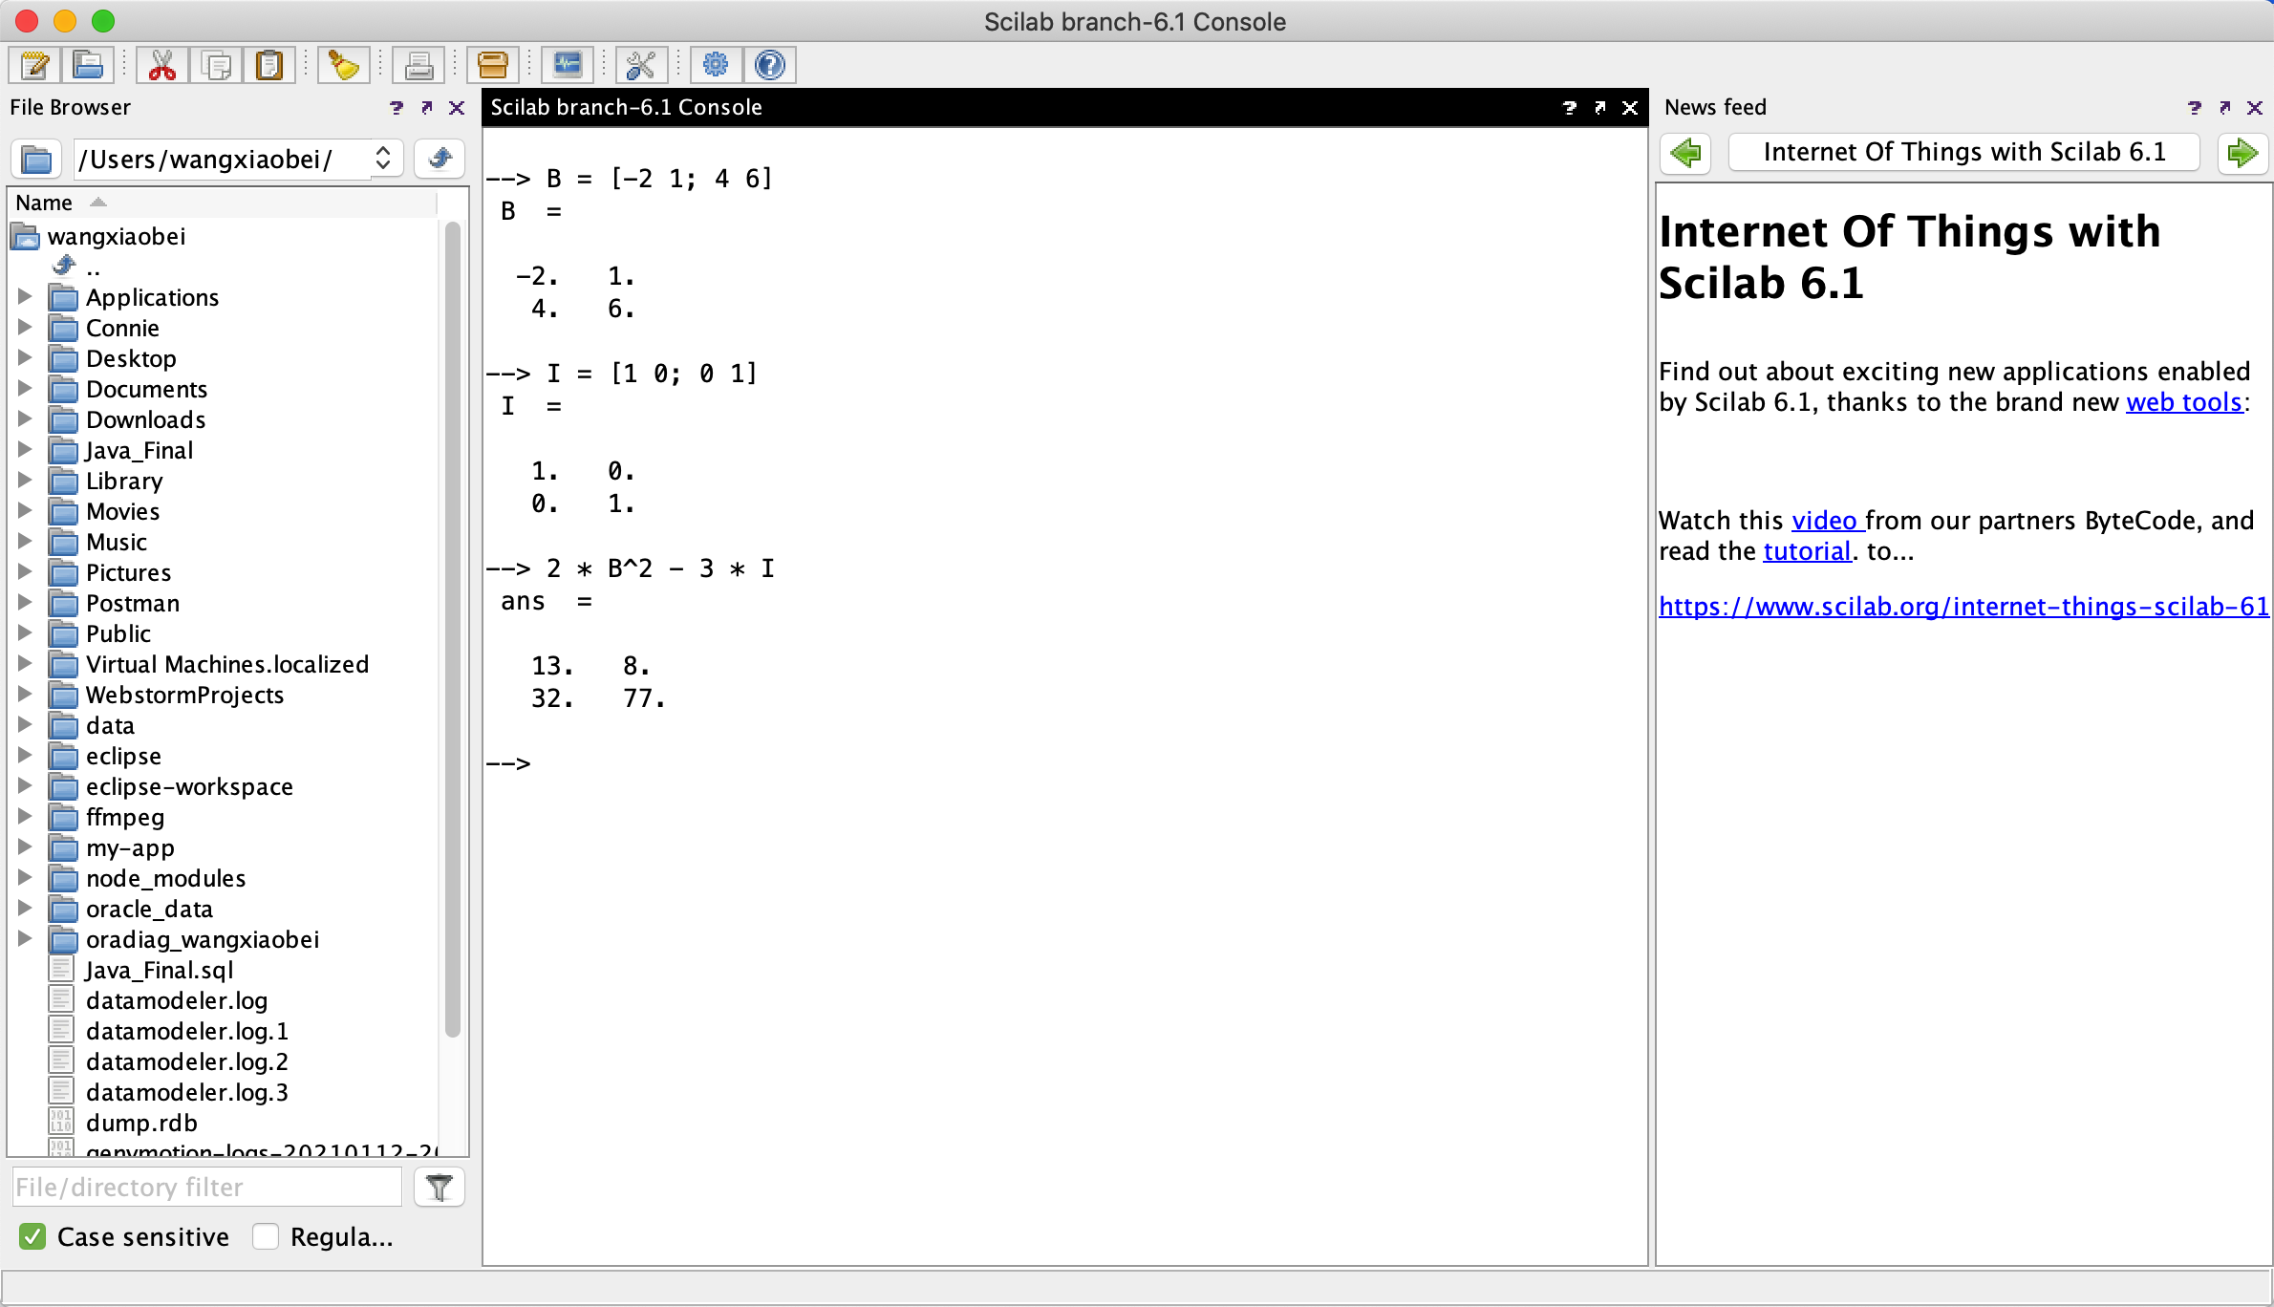

5. Use *SCILAB* to solve the following system of equations and attach SCILAB [3] window environment:

-2x + 2y + z + 3w = 19

5x – y – 2z + w = - 16

x + 3y – 5z + 7w = 2

6x + 9y+8z –2w = 23

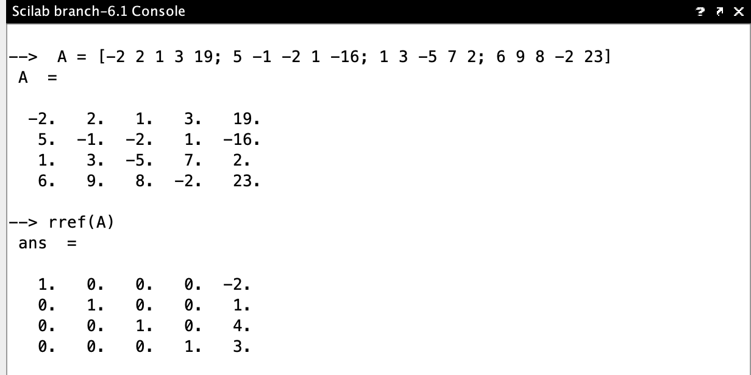

6. Use *SCILAB* to solve the following systems simultaneously and attach SCILAB [3] window environment:

a)

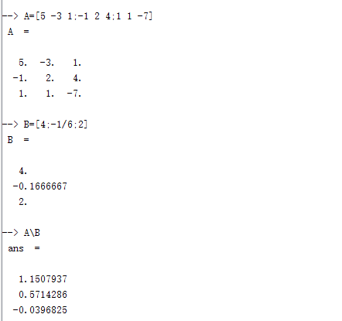

b) 